PRACTICAL: 5

**AIM:** Implement OSPF routing protocol in WAN.

# THEORY:

* Open Shortest Path First (OSPF) is a link-state routing protocol that is used to find the best path between the source and the destination router using its own Shortest Path First).
* OSPF is developed by Internet Engineering Task Force (IETF) as one of the Interior Gateway Protocol (IGP), i.e, the protocol which aims at moving the packet within a large autonomous system or routing domain.

# TOPOLOGY 1:

# 1.jpg

**TOPOLOGY 2:**

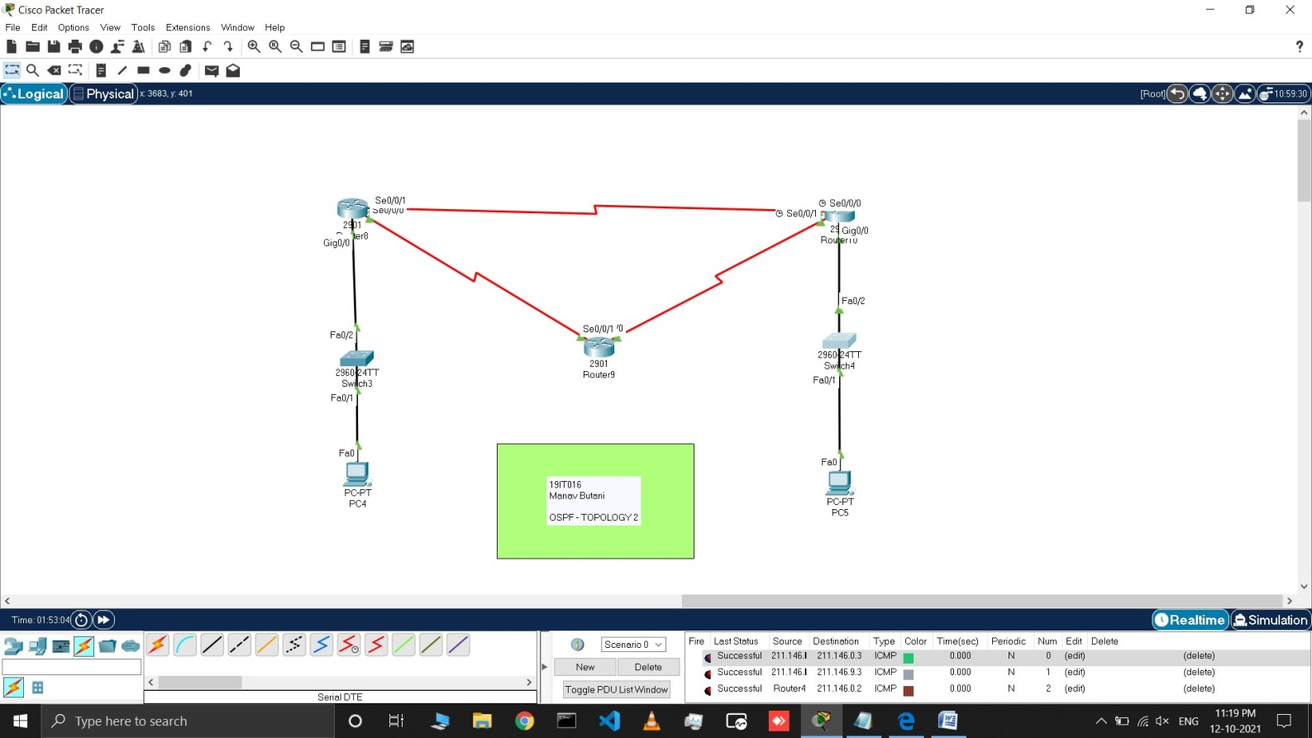

# Questions and answers:

1. **Which network we need to insert into ospf routing for router 0 and router2? Ans:** For router 0 we need to insert following networks :

o 192.168.1.1

o 20.0.0.1

o 30.0.0.1

For router 2 we need to insert following networks :

o 30.0.0.2

o 40.0.0.1

# Mention process id for router 2?

**Ans:** Process id for router 2 is set to 1. For all the router process id is set to 1 and it should be similar in entire toplogy.

# Commands for Topology 1:

* First make the topology as shown in the above figure.

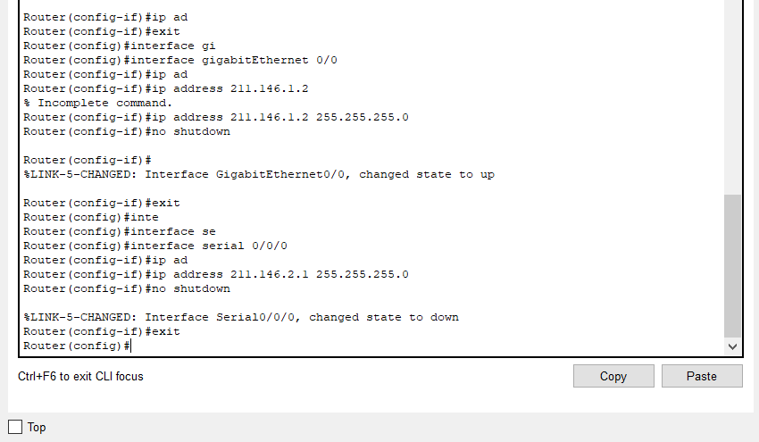

* Now open cli of router 3 and assign all IP address as shown in topology using cmd like
  + enable
  + configure terminal
  + interface <cable type> <cable port>
  + no shutdown

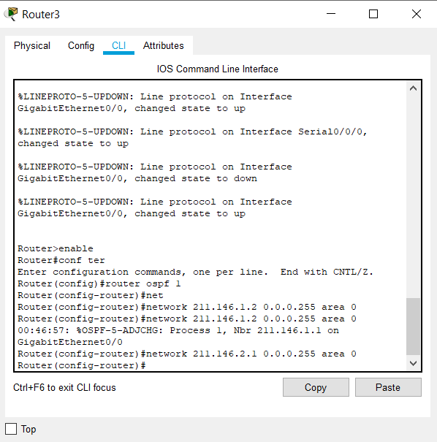

* Now add ospf routing information using **router ospf <process id>** cmd and add each network with their network address using cmd **network <network address>**

**<wildcard subnet> area <area number>**for all the network connected to router 3.

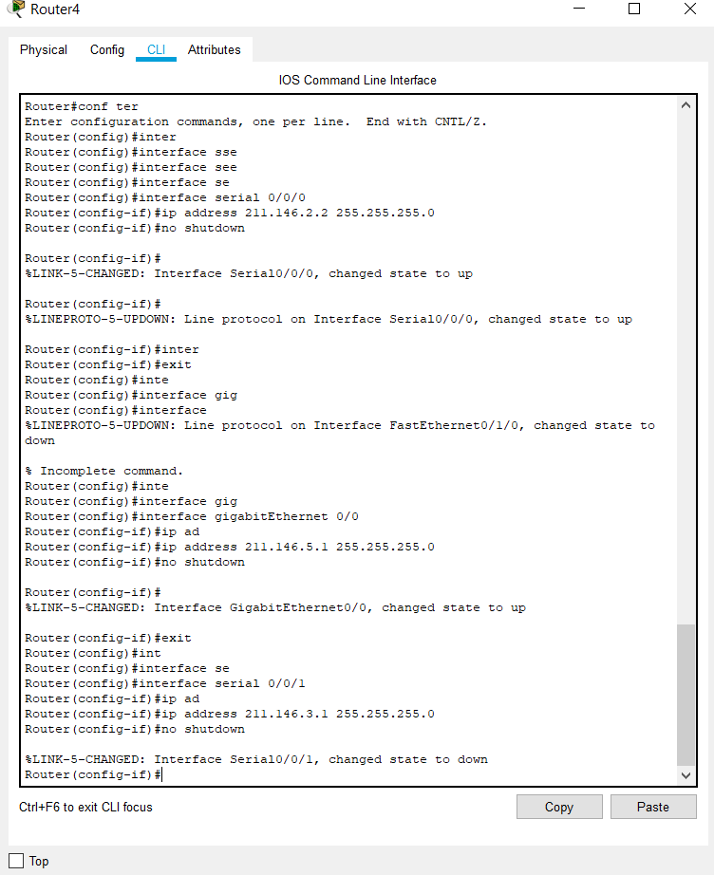

* Now open cli of router4 and assign all IP address as shown in topology using cmd like
  + enable
  + configure terminal
  + interface <cable type> <cable port>
  + no shutdown

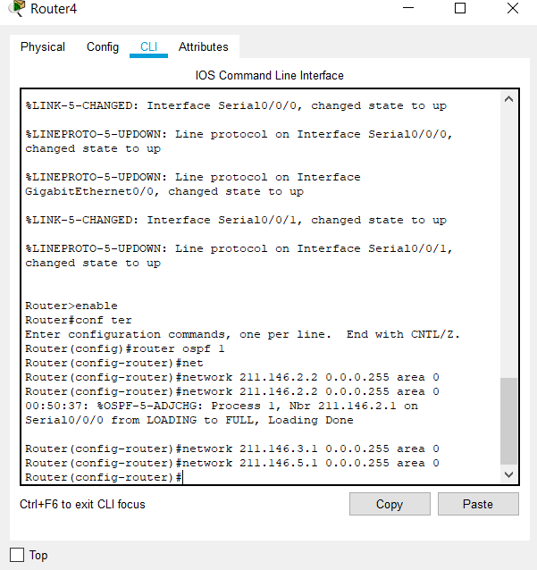

* Now add ospf routing information using **router ospf <process id>** cmd and add each network with their network address using cmd **network <network address>**

**<wildcard subnet> area <area number>**for all the network connected to router 4.

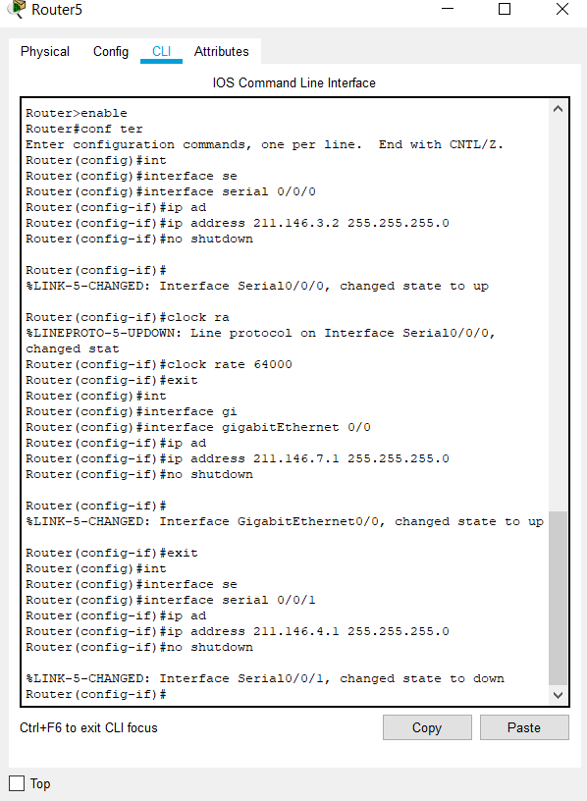

* Now open cli of router 5 and assign all IP address as shown in topology using cmd like
  + enable
  + configure terminal
  + interface <cable type> <cable port>
  + no shutdown

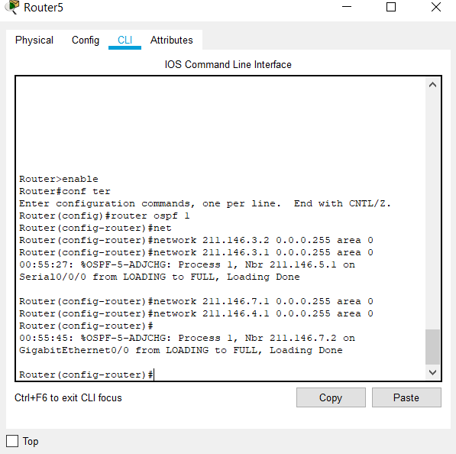

* Now add ospf routing information using **router ospf <process id>** cmd and add each network with their network address using cmd **network <network address>**

**<wildcard subnet> area <area number>**for all the network connected to router 5.

* Likewise do same configuration for router 6,7,8,9 and 10.

# OUTPUTS:

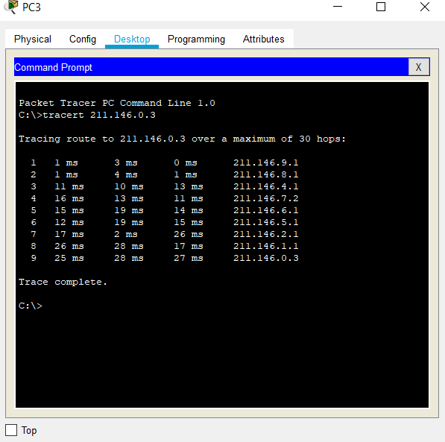

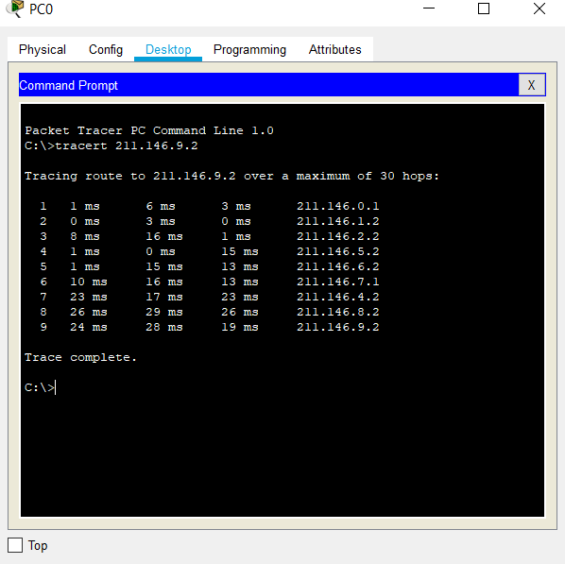

* Here we can see that we are able to transmit our packet to desired target in topology1.

# LATEST APPLICATIONS:

* OSPF is the first widely deployed routing protocol. It can converge with a network in a few seconds, and it is one of the protocols that can provide loop-free paths.
* Open Short Path First is better at load sharing on external links compared to other IGPs. Considering these benefits, it can found widespread use..

# LEARNING OUTCOME:

* Here we learn how to configure ospf routing protocol in a WAN.